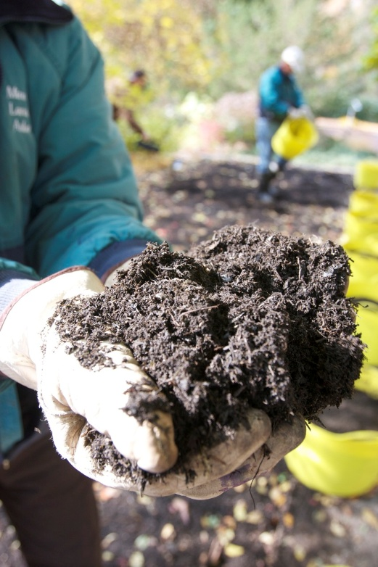
Hennepin County offers free backyard composting classes
Start turning your food scraps and yard waste into compost—right in your own backyard. About 25 percent what we throw away is organic materials like food, napkins and paper towels that could be put to better use as compost. Hennepin County offers free online webinars to help you get started.

Free backyard composting classes
Composting & Recycling Specialist Kira Berglund will share tips for backyard composting in free online webinars. Learn how to set up your compost pile, what materials you can compost, how to get the mix right, and more. There is no charge to sign up, but registration is required.
- Friday, September 25 from noon to 1 p.m. Virtual on Microsoft Teams. Register.
- Tuesday, September 29 from 7 to 8 p.m. Virtual Microsoft Teams. Register.

In-person classes
Hennepin is offering backyard composting classes in partnership with the City of Bloomington and Minneapolis Community Education. Register for one of the following in-person classes:
- Sunday, September 27 from 2 to 3 p.m. at Bloomington Civic Plaza. Register.
- Monday, October 5 from 7 to 8 p.m. at Washburn High School. Register.
Learn more about backyard composting in Hennepin County at HennepinCounty.gov/composting.
Questions? Contact environment@hennepin.us.

